***Movie App***

Web

API: GET

URL: <https://localhost:5001/api/movie>

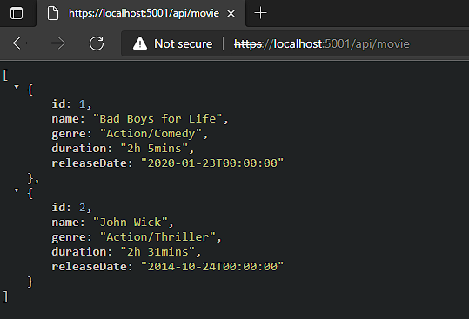

Postman

API: GET

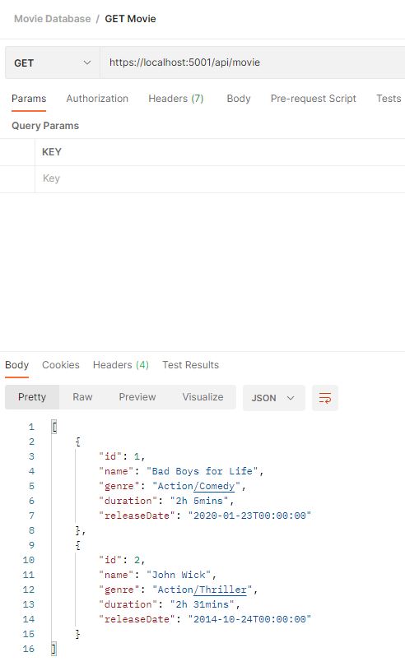URL: <https://localhost:5001/api/movie>

Postman

API: POST

URL: <https://localhost:5001/api/movie>

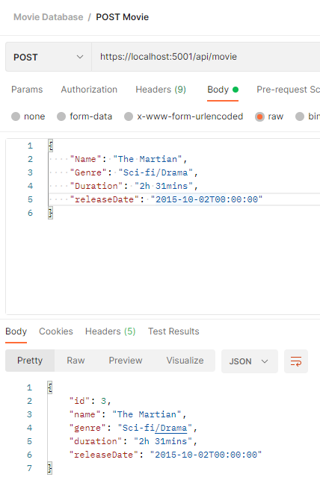

Postman

API: PUT

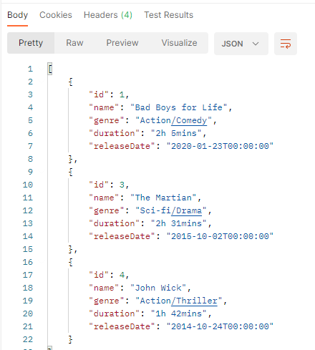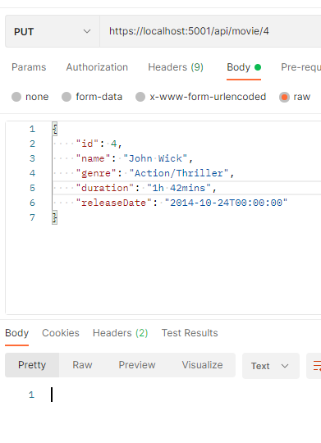URL: https:localhost:5001/api/movie/4

Postman

API: DELETE

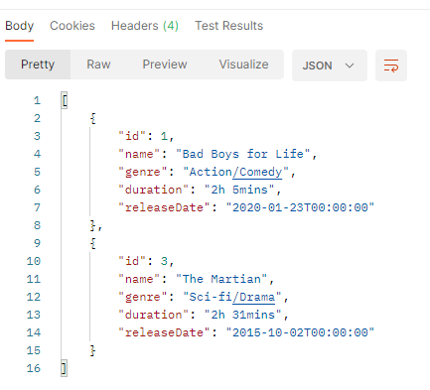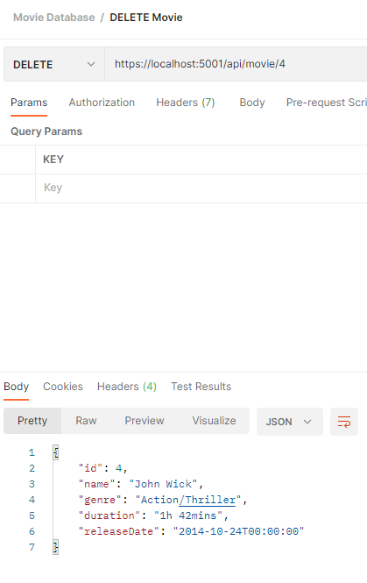URL: https:localhost:5001/api/movie/4

Postman

API: GET

URL: https:/localhost:5001/api/movie/1

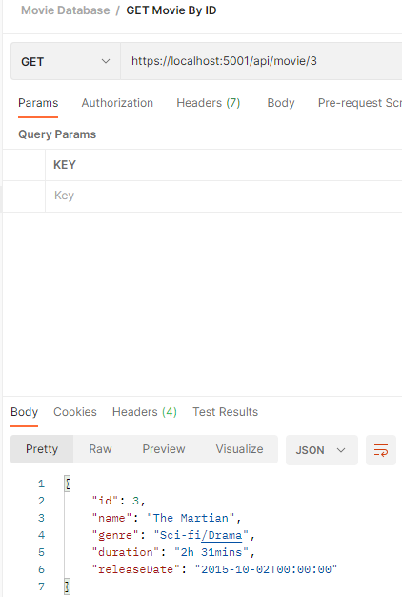

Swagger

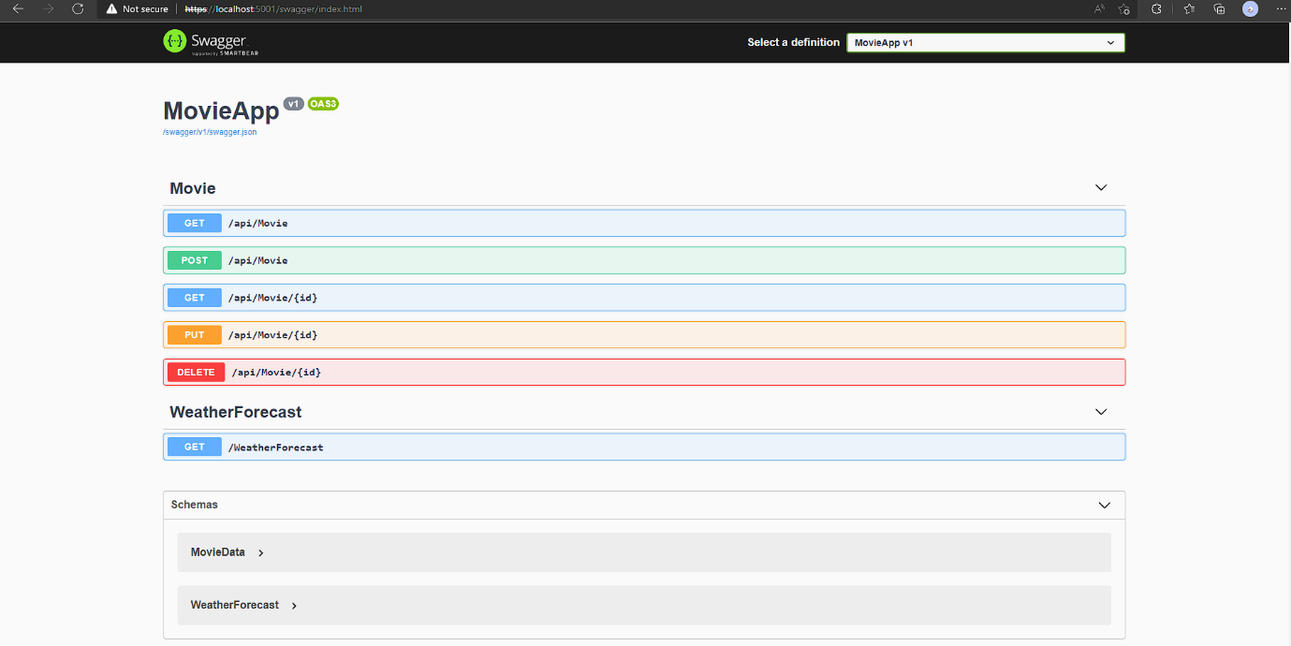

API: GET

URL: api/movie

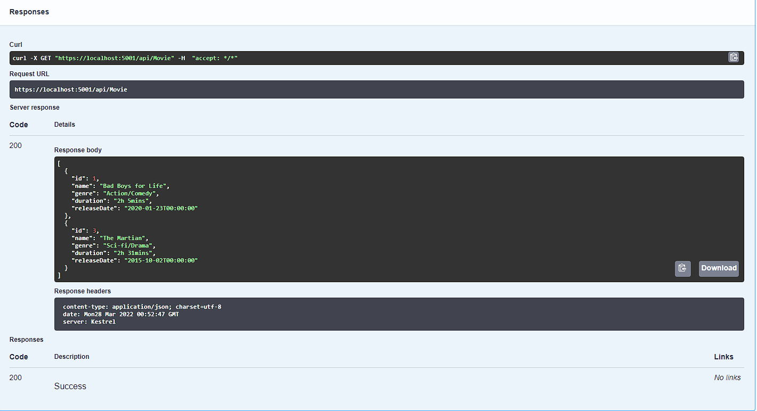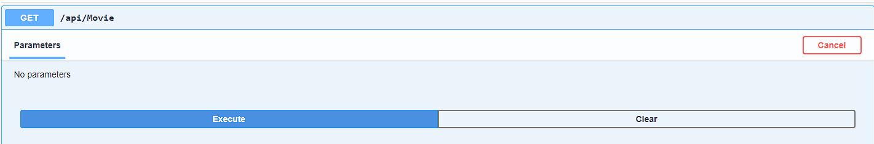

Swagger

API: GET

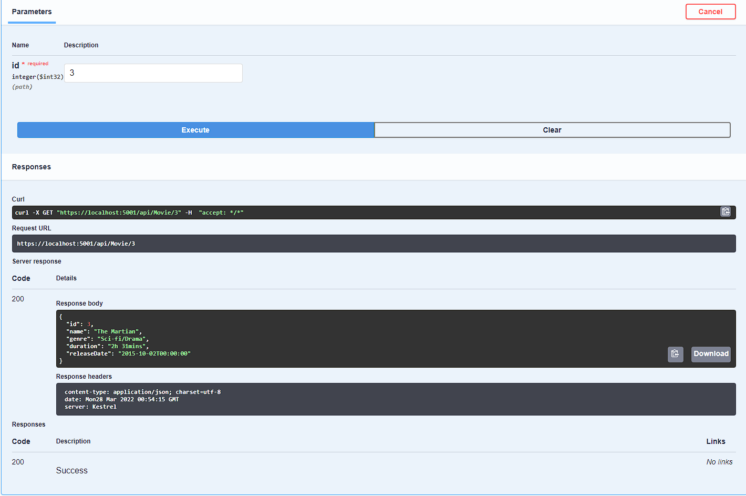URL: api/movie/3

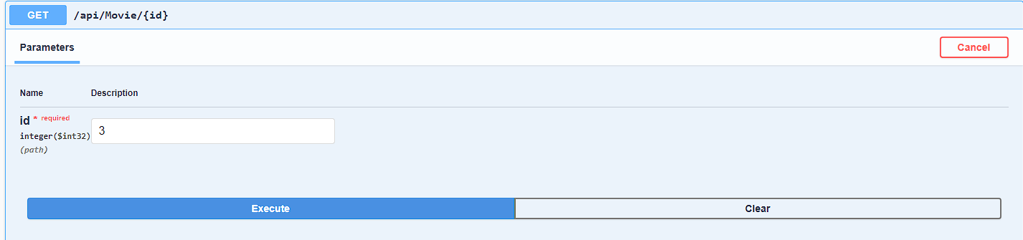

Swagger

API: POST

URL: api/movie

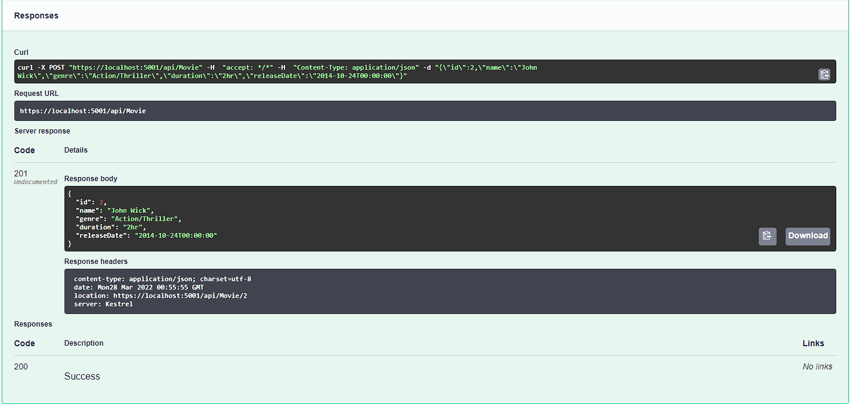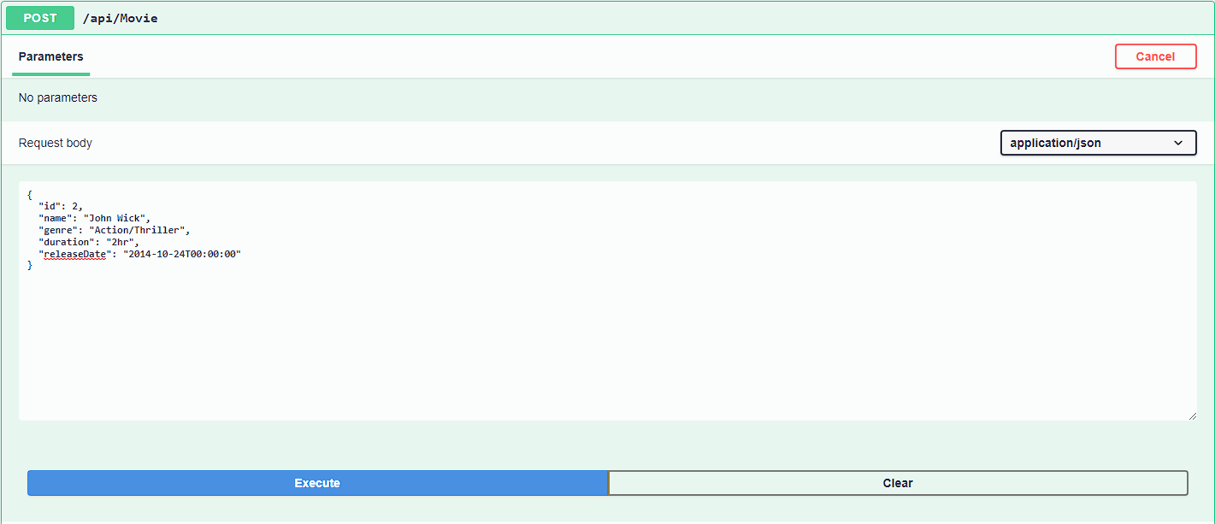

Swagger

API: PUT

URL: api/movie/2

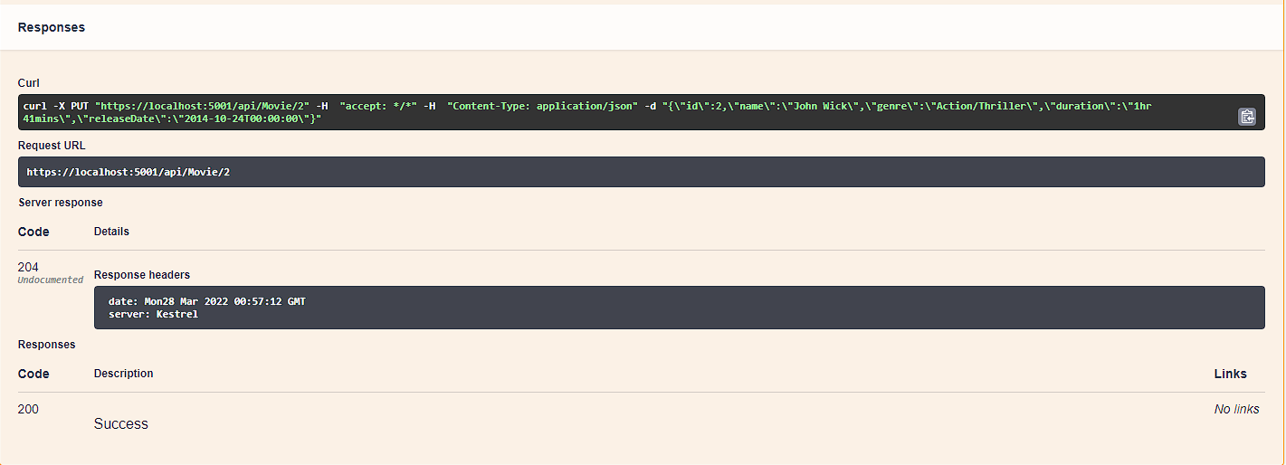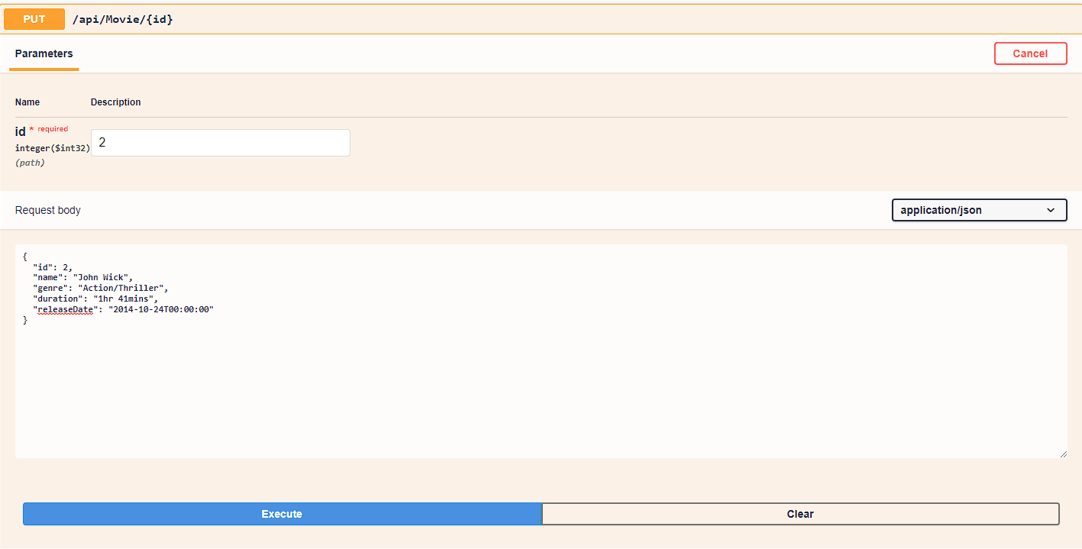

Swagger

API: DELETE

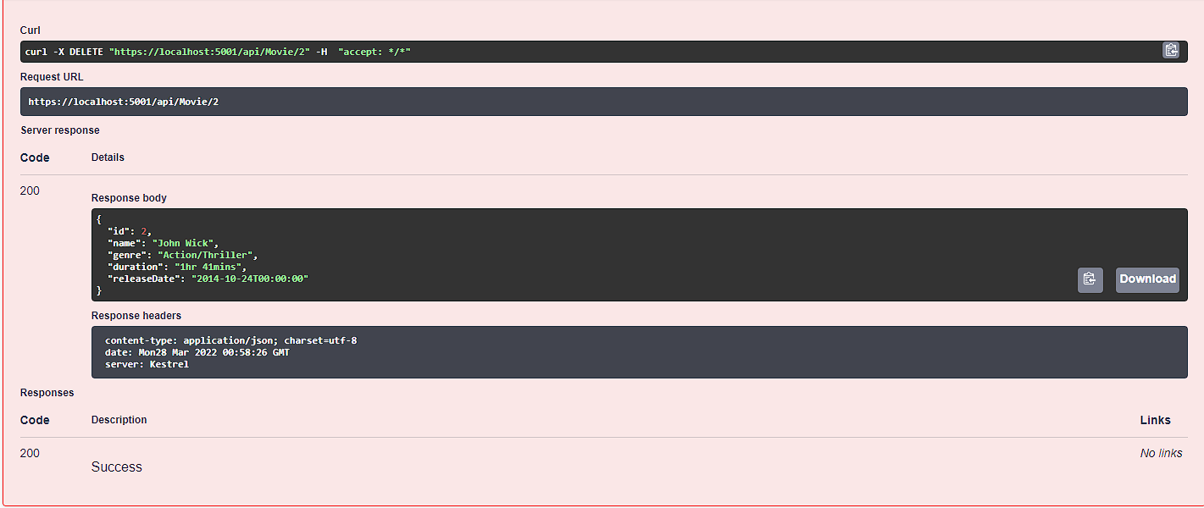URL: api/movie/2

